Futuristic Car Designer
A Project-II Report
Submitted in partial fulfillment of requirement of the Degree of

BACHELOR OF TECHNOLOGY in COMPUTER SCIENCE & ENGINEERING
BY
Mohit Kumar Gupta EN22CS301607 Mohit Chauhan EN22CS301605 Mouli Shukla EN22CS301615 Naman Nayak EN22CS301630 Nikhil Javery EN22CS301647

Under the Guidance of

Prof. Nishant Shrivastava

Prof. Akshay Saxena

Prof. Ajaj Khan


Department of Computer Science & Engineering Faculty of Engineering
MEDICAPS UNIVERSITY, INDORE- 453331 JAN-JUNE 2026

Futuristic Car Designer
A Project-II Report
Submitted in partial fulfillment of requirement of the Degree of

BACHELOR OF TECHNOLOGY in COMPUTER SCIENCE & ENGINEERING
BY
Mohit Kumar Gupta EN22CS301607 Mohit chauhan EN22CS301605 Mouli Shukla EN22CS301615 Naman Nayak EN22CS301630 Nikhil Javery EN22CS301647

Under the Guidance of

Prof. Nishant Shrivastava

Prof. Akshay Saxena

Prof. Ajaj Khan


Department of Computer Science & Engineering Faculty of Engineering
MEDICAPS UNIVERSITY, INDORE- 453331 JAN-JUNE 2026

Report Approval

The project work Futuristic Car Designer is hereby approved as a creditable study of an engineering/computer application subject carried out and presented in a manner satisfactory to warrant its acceptance as prerequisite for the Degree for which it has been submitted.
It is to be understood that by this approval the undersigned do not endorse or approved any statement made, opinion expressed, or conclusion drawn there in; but approve the “Project Report” only for the purpose for which it has been submitted.

Internal Examiner Name: Designation Affiliation

External Examiner Name: Designation Affiliation

Declaration
I/We hereby declare that the project entitled Futuristic Car Designer submitted in partial fulfillment for the award of the degree of Bachelor of Technology in Computer Science and Engineering completed under the supervision of Prof. Nishant Shrivastava, prof. Akshay Saxena and Prof. Ajaj Khan, Assistant Professor and department of Computer Science and Engineering, Faculty of Engineering, Medicaps University Indore is an authentic work.
Further, I/we declare that the content of this Project work, in full or in parts, have neither been taken from any other source nor have been submitted to any other Institute or University for the award of any degree or diploma.

Mohit Chauhan

Mohit Kumar Gupta

Mouli Shukla

Naman Nayak

Nikhil Javery

Certificate (Annexure-F, Remove after finalization)
Certificate

I/We, Prof. Nishant Shrivastava, prof. Akshay Saxena and Prof. Ajaj Khan certify that the project entitled Integrated AI Car Generation System submitted in partial fulfillment for the award of the degree of Bachelor of Technology/Master of Computer Applications by Mohit Chauhan, Mohit Kumar Gupta, Mouli Shukla, Naman Nayak, Nikhil Javery is the record carried out by him/them under my/our guidance and that the work has not formed the basis of award of any other degree elsewhere.

<Name of Internal Guide>
<Name of the Department>
Medicaps University, Indore
<Name of External Guide (If any)>
<Name of the Department>
Name of the Organization

Dr. Kailash Chandra Bandhu Head of the Department Computer Science & Engineering Medicaps University, Indore

Acknowledgements (Annexure-G, Remove after finalization)

Acknowledgements

I would like to express my deepest gratitude to Honorable Chancellor, Shri R C Mittal, who has provided me with every facility to successfully carry out this project, and my profound indebtedness to Prof. (Dr.) D. K. Patnaik, Vice Chancellor, Medicaps University, whose unfailing support and enthusiasm has always boosted up my morale. I also thank Prof. (Dr.) Ratnesh Litoriya, Associate Dean, Faculty of Engineering, Medicaps University, for giving me a chance to work on this project. I would also like to thank my Head of Department Dr. Kailash Chandra Bandhu for his continuous encouragement for the betterment of the project.
I express my heartfelt gratitude to my External Guide, Mr. Manoj Kumar, Project Lead, Honeywell Technology Solutions Lab Pvt. Ltd as well as to my Internal Guide, Prof. Nishant Shrivastava, prof. Akshay Saxena and Prof. Ajaj Khan, Department of Computer Science and Engineering, without whose continuous help and support, this project would ever have reached to the completion.
I would also like to thank to my team at Mohit Kumar Gupta, Mohit Chauhan, Mouli Shukla, Nikhil Javery and Naman Nayak who extended their kind support and help towards the completion of this project.
It is their help and support, due to which we became able to complete the design and technical report. Without their support this report would not have been possible.

Mohit Chauhan Mohit Kumar Gupta Mouli Shukla Naman Nayak Nikhil Javery

B.Tech. IV Year
Department of Computer Science & Engineering Faculty of Engineering
Medi-Caps University, Indore

Abstract
Artificial Intelligence (AI) is transforming digital product design and deployment, but building a complete end-to-end AI system that integrates content generation, automation, and cloud deployment remains a challenge. This project focuses on developing an integrated AI platform that generates car models from user prompts, automatically produces their descriptions, and deploys the application using modern DevOps practices on cloud infrastructure.
The system uses Generative AI to create car models based on user input prompts describing the design, features, or style of a car. To further enhance automation, an Agentic AI module is integrated to automatically generate human-like descriptions of the produced car models. This intelligent agent analyzes the
generated output and provides detailed explanations about the car’s design, characteristics, and potential usage, improving user understanding and reducing manual effort.
To ensure scalability and real-world usability, the complete application is containerized using Docker and deployed on AWS cloud infrastructure. The deployment includes Docker image creation, API integration, and cloud hosting, enabling a reliable and scalable environment for running the application.
The final system demonstrates the integration of Generative AI, Agentic AI, and Cloud DevOps into a single workflow, providing an end-to-end automated platform for design generation, content creation, and deployment. This project highlights how modern AI and cloud technologies can work together to build scalable and intelligent applications for real-world use cases.

Keywords:
Generative Artificial Intelligence (Generative AI), Agentic AI, AI Agents, Text- to-Image Generation, Prompt-Based Design, Automated Content Generation, Cloud Computing, Amazon Web Services (AWS), DevOps, Docker Containerization, REST API Integration, Cloud Deployment, Scalable AI Applications, End-to-End AI System

Contents (Annexure-H, Remove after finalization)

Table of Contents

 |  | Page No.
 | Report Approval | ii
 | Declaration | iii
 | Certificate | iv
 | Acknowledgement | v
 | Abstract | vi
 | Table of Contents | vii
 | List of figures | viii
 | List of tables | ix
 | Abbreviations | x
 | Notations & Symbols | xi
Chapter 1 | Introduction (Whichever is applicable)
 | 1.1 Introduction | 1
 | 1.2 Literature Review
 | 1.3 Objectives
 | 1.4 Significance
 | 1.5 Research Design
 | 1.6 Source of Data
 | 1.7 Chapter Scheme
Chapter 2 | (Report on Present Investigation)
 | 2.1 Experimental Set-up
 | 2.2 Procedures Adopted
 | 2.3
Chapter 3 | (Main Chapter)
 | 3.1
Chapter 4 | Main Chapter (Optional)
Chapter 6 | Main Chapter (Optional)
Chapter 6 | Main Chapter (Optional)
Chapter 7 | Results and Discussions
Chapter 8 | Summary and Conclusions
Chapter 9 | Future scope
 | Appendix
 | Bibliography
 | List of Publications (If any)
 | Reprints of publications(If any)
Note | Results and Discussions may not be a separate chapter it may be  included in main chapter

List of Figures

Figure 1.1 – Overall System Overview of AI Car Generation Platform Figure 2.1 – Workflow of Generative AI Car Model Generation Figure 2.2 – Agentic AI Description Generation Process
Figure 2.3 – Integrated System Workflow Figure 3.1 – System Architecture Diagram Figure 3.2 – API Integration Workflow Figure 3.3 – Docker Container Architecture Figure 3.4 – AWS Cloud Deployment Pipeline Figure 4.1 – User Prompt Input Interface Figure 4.2 – Generated Car Model Output
Figure 4.3 – Agentic AI Generated Description Output Figure 4.4 – Running Application in Docker Container Figure 4.5 – Application Hosted on AWS Cloud Figure 5.1 – End-to-End Working of the System

List of Tables

No. | Table Title | Location (Chapter:Section) | Content Description
1 | Tools and Technologies Used | Chapter 2 | Programming languages, AI tools, Docker and AWS used in the project
2 | System Modules Description | Chapter 3 | Overview of Generative AI, Agentic AI and DevOps modules
3 | API Integration and Data Flow | Chapter 3 | Communication flow between frontend, AI modules and cloud
4 | Docker Configuration | Chapter 3 | Docker image creation and container setup details
5 | AWS Deployment Environment | Chapter 3 | Cloud deployment configuration and hosting setup
6 | Summary of System Results | Chapter 4 | Final system capabilities and outcomes
7 | Future Enhancements Overview | Chapter 5 | Planned improvements and future work

Abbreviations

Abbreviation | Full Term
AI | Artificial Intelligence
GenAI | Generative Artificial Intelligence
Agentic AI | Autonomous AI Agent Systems
AWS | Amazon Web Services
API | Application Programming Interface
REST | Representational State Transfer
UI | User Interface
CI/CD | Continuous Integration and Continuous Deployment
GPU | Graphics Processing Unit
JSON | JavaScript Object Notation
Docker | Containerization Platform
Cloud | Cloud Computing Infrastructure

Notations & Symbols

Notation | Description | Context
P | User Prompt Input | Car generation input
G | Generated Car Model | Output of Generative AI
A | AI Agent | Agentic AI module
D | Generated Description | Output of Agentic AI
API | Application Programming Interface | Communication between modules
C | Docker Container | Containerized application
I | Docker Image | Packaged application
S | Cloud Server | AWS deployment
U | User Interface | Frontend interaction
R | Response Output | Final system output

Chapter 1: Introduction
This chapter provides the foundational overview of the project. It explains the motivation behind the development of an AI-powered car generation system, reviews relevant technological advancements, and defines the objectives that guide the system design and implementation.

Introduction
Artificial Intelligence (AI) has rapidly evolved into one of the most transformative technologies in modern software engineering. In recent years, Generative AI has enabled machines to create images, designs, and structured outputs based on natural language prompts, significantly reducing manual effort in creative and design processes. Alongside this, Agentic AI has introduced autonomous systems capable of reasoning, decision-making, and executing multi- step tasks without continuous human intervention.
This project focuses on developing an AI-powered Car Generation System that integrates Generative AI, Agentic AI, and Cloud computing into a unified workflow. The system allows users to input natural language prompts such as “sports car with futuristic design”, and automatically generates corresponding car models. In addition to image generation, an AI agent enhances the output by producing structured descriptions of the generated car, making the system more interactive and informative.
To ensure real-world applicability, the system is containerized using Docker and deployed on a cloud platform (AWS), following modern DevOps practices. This ensures scalability, portability, and efficient deployment of the application.
The combination of Generative AI, Agentic AI, and cloud infrastructure makes this system a complete end-to-end intelligent pipeline that demonstrates how AI can be applied in real-world product design and simulation.

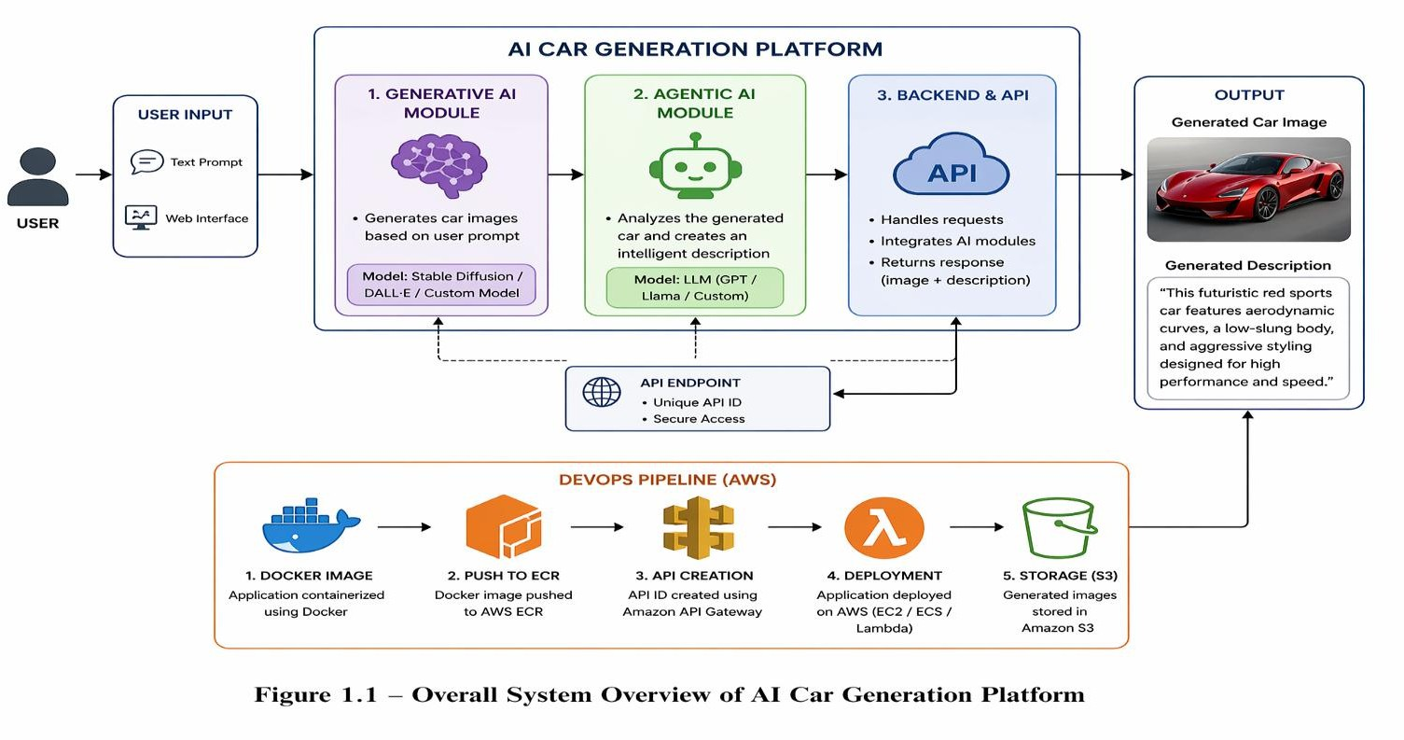

Figure 1.1 – Overall System Overview of AI Car Generation Platform
-Illustrates the complete workflow of the Integrated AI Car Generation System. The process begins with a user entering a text prompt through the web interface. The Generative AI module converts this prompt into a realistic car image, while the Agentic AI module analyzes the generated design and produces a detailed description explaining its features and style.
The DevOps pipeline then containerizes the application using Docker, pushes the image to AWS ECR, creates an API ID via Amazon API Gateway, and deploys the system on AWS Cloud for scalable access. This figure provides a holistic view of how creativity, reasoning, and deployment are integrated into one intelligent platform.

Literature Review (Problem Justification)
Recent advancements in Generative AI have enabled the creation of high-quality synthetic images using models such as diffusion models, GANs (Generative Adversarial Networks), and transformer-based architectures. These models have been widely used in domains such as digital art generation, product design, and automotive visualization.
Similarly, Agentic AI systems have gained attention for their ability to perform autonomous reasoning and task execution. These systems are designed to break down complex tasks into smaller steps, execute them sequentially, and produce meaningful outputs without continuous human supervision.

In the field of cloud computing and DevOps, containerization technologies such as Docker and orchestration platforms like AWS have revolutionized application deployment. These technologies enable developers to build scalable, portable, and production-ready systems.
However, most existing systems focus on either Generative AI or deployment pipelines independently. Very few solutions integrate Generative AI + Agentic AI + Cloud deployment into a single unified architecture. This project addresses this gap by combining all three technologies into one end-to-end system, enabling both intelligent generation and scalable deployment.

Objectives
The primary objective of this project is to design and develop an AI-powered system that generates car models from text prompts and enhances them using autonomous AI agents. The specific objectives are as follows:

Generative Model Development:
To design a Generative AI system capable of creating realistic car designs based on user text prompts.

Agentic AI Integration:
To implement an AI agent that automatically analyzes generated car models and produces structured descriptions.

System Integration:
To integrate Generative AI and Agentic AI modules using APIs for seamless communication between components.

Containerization and Deployment:
To containerize the application using Docker and deploy it on AWS cloud infrastructure for scalability and reliability.

Interactive User Interface:
To develop a user-friendly interface that allows users to input prompts and view generated outputs in real time.

End-to-End AI Pipeline:
To build a fully automated system that transforms user input into visual and textual outputs without manual intervention.

  - Significance and Scope Significance
This project demonstrates the practical integration of multiple advanced technologies including Generative AI, Agentic AI, and cloud computing. It highlights how AI can be used not only for content generation but also for autonomous reasoning and deployment automation.
The system provides a foundation for intelligent product design platforms where users can visualize and describe products in real time. It also showcases how AI- driven systems can be deployed in scalable environments using DevOps practices, making them suitable for real-world applications.
Scope
    - Scope:
The system focuses on generating car designs from text prompts and producing AI-generated descriptions for each output. It demonstrates the feasibility of combining generative and agentic systems into a unified pipeline.
    - Limitations:
The current system is a prototype and may not produce highly detailed engineering-level automotive designs. Its output quality depends on the underlying generative model and training data. Additionally, real-time optimization and advanced 3D modeling are outside the current scope but can be considered in future enhancements.

Chapter 2: Methodology and Implementation
This chapter explains the technical framework, system architecture, and implementation methodology of the proposed AI-powered Car Generation System. The system integrates Generative AI, Agentic AI, API-based communication, containerization using Docker, and cloud deployment on AWS. The implementation follows a structured pipeline focusing on prompt processing, AI-based generation, automated reasoning, and scalable deployment.

Overview of Methodology
The methodology of the project is designed as a multi-stage intelligent pipeline that converts user input into a fully generated car design along with an AI- generated description.
The system follows three major phases:
- Prompt Processing and Input Handling — Accepting and preprocessing user text prompts describing desired car designs.
- Generative AI Model Execution — Generating visual car models based on the processed input.
- Agentic AI Reasoning and Output Generation — Automatically analyzing generated outputs and producing structured descriptions.
This structured pipeline ensures that the system is not only generative but also intelligent and self-explanatory, combining creativity with reasoning.
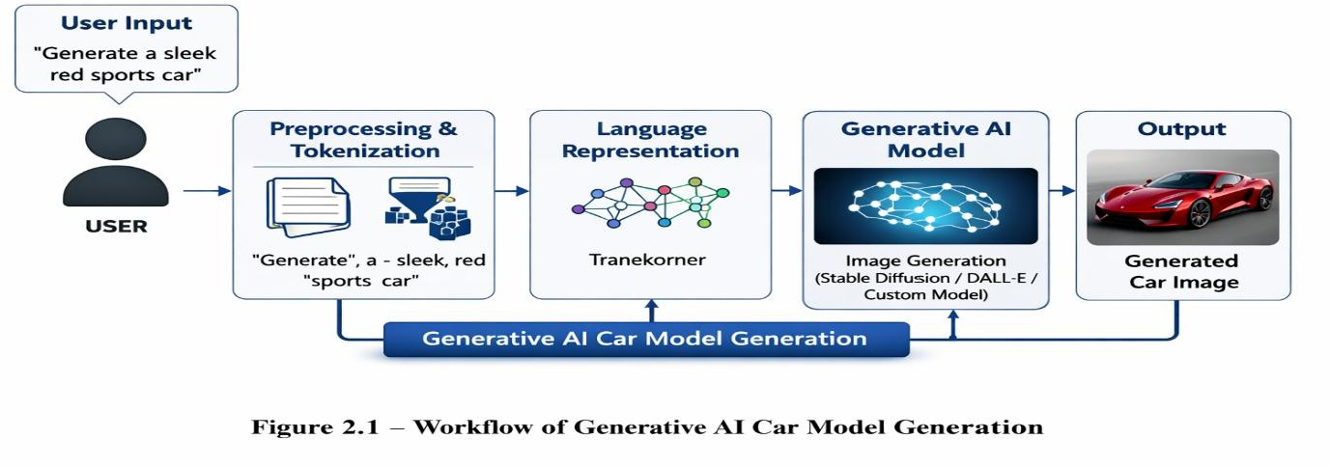

Figure 2.1 – Workflow of Generative AI Car Model Generation

As shown in Figure 2.1, the workflow of the Generative AI Car Model Generation
begins with the user providing a text prompt such as
‘Generate a sleek red sports car’.
The system preprocesses and tokenizes the prompt to remove unnecessary characters and standardize the format. The refined text is converted into language representations using transformer-based models.
These representations are then passed into the Generative AI engine
(e.g., Stable Diffusion, DALL·E, or a custom model) to synthesize a realistic car image that matches the user’s description. The final output is a high-quality car model image ready for further analysis or integration with the
Agentic AI module.”

Dataset and Input Preparation
    - Input Source Description
Unlike traditional machine learning systems, this project is primarily prompt- driven rather than dataset-driven. The system relies on user-generated natural language prompts such as:
      - “Futuristic electric sports car with neon lights”
      - “Luxury SUV with aerodynamic design”
      - “Off-road vehicle with military style”
These prompts act as dynamic input data for the Generative AI model.

Prompt Preprocessing
Before sending the input to the AI model, the following preprocessing steps are applied:
      - Removal of unnecessary special characters
      - Standardization of text format
      - Tokenization of input prompt
      - Enhancement using prompt engineering techniques
This ensures that the Generative AI model receives clean and optimized input for better output quality.

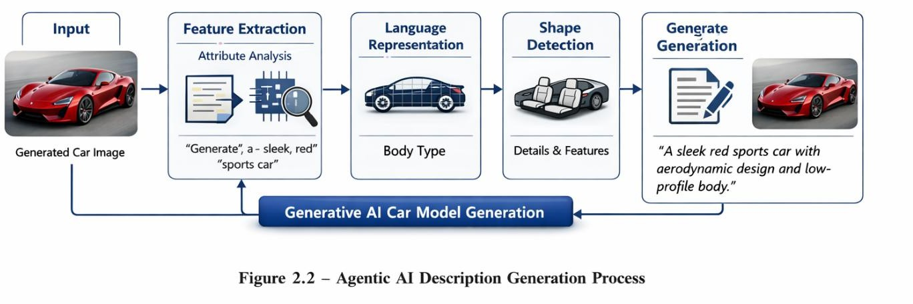

Figure 2.2 – Agentic AI Description Generation Process
“As shown in Figure 2.2, the Agentic AI Description Generation Process begins with a generated car image as input. The system performs feature extraction, analyzing visual attributes such as color, design, and body type.
These extracted features are processed through three analytical stages —
Style Analysis, Shape Detection, and Feature Identification — to interpret the
car’s aesthetic and structural characteristics.
Finally, the Agentic AI module synthesizes this information into a
natural-language description, producing human-readable text such as ‘A sleek red sports car with aerodynamic design and low-profile body.’ This structured approach ensures that the system’s outputs are both visually accurate and
descriptively rich.”

System Architecture

Multi-Layer Architecture Design
The system follows a modular architecture consisting of four main layers:
      - Frontend Layer: Streamlit-based user interface for input and output display
      - API Layer: Handles communication between frontend and AI modules
      - AI Processing Layer: Includes Generative AI and Agentic AI modules
      - Deployment Layer: Docker containerization and AWS cloud hosting

Workflow Overview:
User Prompt
↓
API Processing
↓
Generative AI Model
↓
Car Image Generation
↓
Agentic AI Module
↓
Description Generation
↓
Response Display (UI)
↓
Docker + AWS Deployment
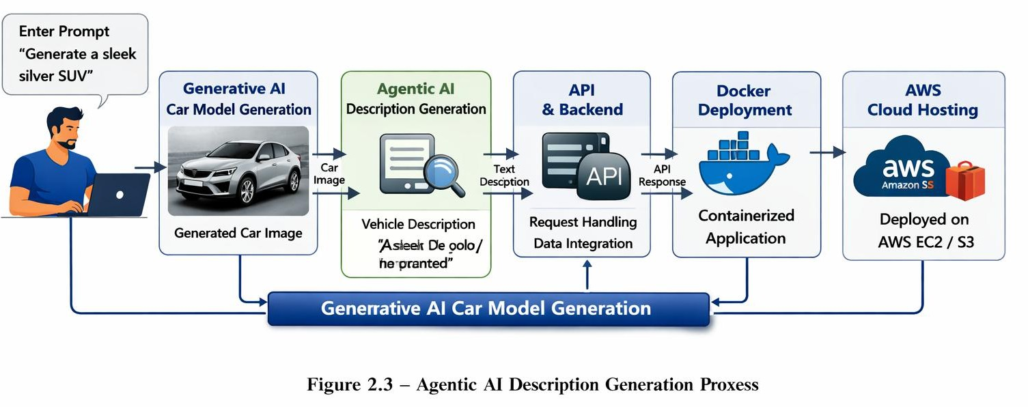

Figure 2.3 – Integrated System Workflow
Figure 2.3 shows how the system connects all modules. The user enters a prompt, which passes through the Generative AI module to create a car image.
The Agentic AI module then generates a description. Finally, the DevOps pipeline (API Integration, Docker, AWS) deploys the application, making the output accessible on the cloud.

​Model Architecture

Generative AI Module
The Generative AI component is responsible for creating visual representations of cars based on text prompts.
Key Features:
      - Text-to-Image generation capability
      - Prompt-based creative design generation
      - High-resolution output synthesis
      - Style adaptation based on input context
This module forms the core creative engine of the system.

Agentic AI Module
The Agentic AI module acts as an autonomous reasoning system that enhances interpretability of generated outputs.
Working Principle:
- Receives generated car image and prompt
- Analyzes visual attributes such as shape, style, and features
- Applies reasoning to interpret design characteristics
- Generates structured natural language description Output Example:
  - “A futuristic sports car with aerodynamic curves and LED lighting system
designed for high-speed performance.”
This makes the system more intelligent and user-friendly.

API Integration Layer
All components communicate through RESTful APIs. Functions include:
      - Sending prompts to Generative AI
      - Receiving generated outputs
      - Passing data to Agentic AI module
      - Returning final response to frontend
This ensures modularity and scalability of the system.

Implementation and Deployment

Frontend Implementation
A Streamlit-based interface is developed for user interaction. Features:
      - Text input for car generation prompts
      - Display of generated car images
      - AI-generated descriptions
      - Real-time response visualization

Containerization using Docker
The entire application is containerized using Docker to ensure consistency across environments.
Process:
- Application dependencies defined in Dockerfile
- Image built using base Python environment
- Container created with all modules integrated
- Application runs consistently across systems

Benefits:
  - Portability
  - Environment consistency
  - Easy deployment

Cloud Deployment (AWS)
The Docker container is deployed on AWS cloud infrastructure. Deployment steps:
      - Docker image pushed to cloud environment
      - Instance configured on AWS
      - Application hosted for public access
      - Scalable deployment enabled Benefits:
      - High availability
      - Scalability
      - Remote accessibility

Tools and Technologies Used

Category | Tool / Technology | Purpose / Usage
Programming Language | Python | Core development language for backend logic and AI integration
Frontend Framework | Streamlit | User interface for prompt input and output visualization
Backend Framework | FastAPI | REST API communication between frontend, AI modules, and cloud
Generative AI | Stable Diffusion / DALL·E | Text-to-image generation for car model creation
Agentic AI | LLM (GPT /  Custom Models) | Autonomous reasoning and description generation of car models
Containerization | Docker | Packaging application code and dependencies into portable containers
Cloud Platform | AWS (EC2,  Lambda, S3, ECR) | Hosting, deployment, storage, and scalability of the application
Version Control | Git / GitHub | Source code management, collaboration, and repository hosting

  - Summary
This chapter described the methodology and implementation details of the AI- powered Car Generation System. The system integrates Generative AI for visual output generation and Agentic AI for intelligent reasoning and description creation. The application is structured using a modular API-based architecture and deployed using Docker and AWS for scalability and real-world usability.
The combination of AI generation, autonomous reasoning, and cloud deployment makes the system a complete end-to-end intelligent application, demonstrating the practical integration of modern AI technologies.

Chapter 3: Methodology and Implementation
This chapter provides a detailed description of the technical methodology used to develop the AI-powered Car Generation System. It explains the system architecture, prompt processing pipeline, Generative AI and Agentic AI integration, API communication, and deployment strategy using Docker and AWS. The focus is on building an end-to-end intelligent system that converts natural language prompts into visual outputs and structured descriptions.

System Overview and Methodology
The proposed system follows a modular and multi-stage pipeline that integrates Generative AI, Agentic AI, and cloud deployment technologies. The methodology is divided into three main phases:
- User Input and Prompt Processing — Accepting and refining natural language prompts from users.
- Generative AI Execution — Generating car designs based on processed prompts.
- Agentic AI Reasoning and Output Generation — Producing structured descriptions of generated cars.
This structured pipeline ensures that the system is both creative and intelligent, combining visual generation with contextual reasoning.
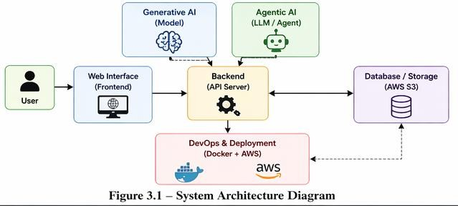

Figure 3.1 – System Architecture Diagram

This diagram illustrates four layers — Frontend UI (Streamlit), API Layer (FastAPI), AI Processing Layer (Generative AI + Agentic AI), and Deployment Layer (Docker + AWS) — showing how data flows from user input to cloud deployment.

Table 3.1 – System Modules Description

Module | Description | Role in System
Generative AI | Text-to-Image model (e.g., Stable Diffusion / DALL·E) that converts user prompts into car designs. | Core creative engine that generates realistic car models from natural language input.
Agentic AI | Autonomous reasoning module (LLM-based) that analyzes generated car images and produces structured descriptions. | Enhances interpretability by explaining car features, style, and usability in  human-readable text.
DevOps Module | Docker containerization and AWS cloud deployment pipeline.  Includes API integration, image hosting, and scalability. | Ensures portability, scalability, and real-world usability of the application.

Table 3.1 provides an overview of the three main modules of the Integrated AI Car Generation System. Each module plays a distinct role in ensuring that the system is creative, intelligent, and deployable in real-world environments.

Input Design and Prompt Processing

Input Source
The system is entirely prompt-driven, where users provide textual descriptions of desired car designs. Examples include:
      - “Futuristic electric sports car with aerodynamic wings”
      - “Luxury SUV with matte black finish and LED lighting”
      - “Off-road military vehicle with armored structure”
These prompts act as the primary input for the Generative AI model.

Table 3.2 – API Integration and Data Flow

Component | Data Flow | Purpose / Role
Frontend (Streamlit UI) | Sends user prompts as JSON requests to backend API. | Provides user interface for input and displays generated outputs.
Backend (FastAPI) | Receives requests from frontend, validates input, and routes to AI modules. | Acts as middleware ensuring smooth communication between UI and AI services.
Generative AI Module | Accepts prompt data from backend, processes it, and returns car image output. | Generates realistic car models based on user text prompts.
Agentic AI Module | Receives generated car image and prompt, analyzes features, and returns description. | Produces structured textual descriptions to enhance interpretability.
Cloud Services (AWS) | Stores outputs (images + descriptions) and hosts APIs for public access. | Ensures scalability, availability, and secure hosting of application.
API Response | Combines car image + description into a single response sent back to frontend. | Delivers final integrated output to the user in real time.

Prompt Preprocessing
Before sending the input to the AI model, the system performs several preprocessing steps to ensure clarity and optimal performance:
      - Removal of unnecessary symbols and noise
      - Standardization of text format
      - Tokenization of input prompt
      - Prompt enhancement using keyword expansion techniques
This ensures that the Generative AI model interprets the input correctly and generates high-quality outputs.
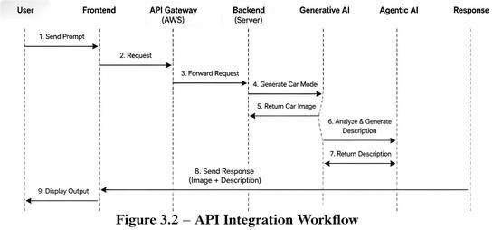
Figure 3.2 depicts how the frontend sends JSON requests to the backend via FastAPI. The backend routes data to Generative AI and Agentic AI services, receives responses, and returns them to the user interface.

System Architecture

Multi-Layer Architecture Design
The system is designed using a layered architecture to ensure modularity and scalability:
      - Frontend Layer: Streamlit-based user interface for input and output visualization
      - API Layer: RESTful APIs for communication between components

      - AI Processing Layer: Includes Generative AI and Agentic AI modules
      - Deployment Layer: Docker containerization and AWS cloud hosting
Workflow Structure:

User Input (Text Prompt)
↓
API Request Handling
↓
Generative AI Module
↓
Car Image Generation
↓
Agentic AI Module
↓
Structured Description Generation
↓
Frontend Display
↓
Docker + AWS Deployment
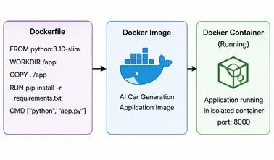

Figure 3.3 – Docker Container Architecture
This figure shows how the application code, dependencies, and libraries are
packaged inside a Docker container. The container runs on Docker Engine over the host OS, ensuring portability and consistency across environments.

Table 3.3 – Docker Configuration

Step | Configuration Detail | Purpose / Role
Dockerfile Creation | Define base image (Python), install dependencies (Streamlit, FastAPI, AI libraries). | Ensures all required packages are included in the container.
Image Build | docker build -t ai-car-generator . | Creates a Docker image with application code and dependencies.
Container Setup | docker run -p 8501:8501 ai-car- generator | Runs the application inside an isolated container environment.
Environment Variables | .env file used for API keys (Gemini, Pollinations, AWS). | Provides secure configuration management inside the container.
Port Mapping | Map container ports (e.g., 8501 for Streamlit, 8000 for FastAPI). | Allows external access to application services.
Volume Mounting | Optional: -v  /local/path:/container/path | Enables persistent storage and sharing of files between host and container.
Image Push | docker push /ai-car-generator | Uploads Docker image to AWS ECR for cloud deployment.

  - Generative AI Model Implementation
    - Model Functionality
The Generative AI module serves as the core creative engine of the system. It transforms text prompts into realistic and visually appealing car designs.
Key capabilities include:

      - Text-to-image generation
      - Style adaptation based on prompt context
      - High-resolution output synthesis
      - Automotive design simulation
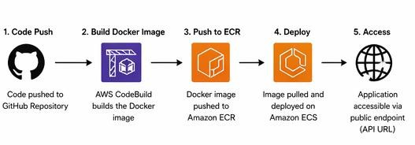

Figure 3.4 – AWS Cloud Deployment Pipeline
Figure 3.4 outlines the DevOps process: Docker image creation → push to ECR
→ API Gateway setup → deployment on EC2/Lambda → storage in S3. This
enables scalable and secure cloud hosting.

Working Mechanism
The process followed by the Generative AI model includes:
- Receiving user prompt
- Encoding textual information into latent representation
- Mapping latent space to visual features
- Generating car image output
- Returning final rendered design
This ensures that each output is unique and contextually aligned with the user’s
input.

Table 3.4 – AWS Deployment Environment

Component | Configuration Detail | Purpose / Role
Docker Image Push | Application image pushed to Amazon ECR (Elastic Container Registry). | Stores container images securely for deployment on AWS.
API Gateway | Configured with unique API ID to route requests. | Provides secure access to backend services via REST endpoints.
Compute Services | Deployed on AWS EC2 / ECS / Lambda depending on scaling needs. | Executes application workloads in the cloud.
Storage Service | Generated car images and descriptions stored in Amazon S3 buckets. | Ensures persistent storage and easy retrieval of outputs.
Networking & Security | Configured with IAM roles, VPC, and security groups. | Provides secure communication and controlled access to resources.
Monitoring & Logging | Integrated with CloudWatch for logs and performance metrics. | Tracks application health and ensures reliability.

  - Agentic AI Module
    - Role of Agentic AI
The Agentic AI module acts as an autonomous reasoning system that enhances the interpretability of generated car designs.
Its responsibilities include:
      - Analyzing generated car images
      - Extracting design attributes (shape, style, features)
      - Understanding user intent from prompts
      - Generating structured textual descriptions

Working Process
The Agentic AI follows a multi-step reasoning pipeline:
- Receives generated car image and original prompt
- Performs feature interpretation and analysis
- Identifies key design elements (e.g., sporty, futuristic, luxury)
- Generates human-readable description
Output Example:

“A futuristic sports car with aerodynamic curves, glowing LED headlights, and a low-profile body designed for high-speed performance.”
  - API Integration and Communication
The system uses RESTful APIs to connect all modules. Key Functions:
- Sending prompts to Generative AI
- Receiving generated car images
- Passing outputs to Agentic AI
- Returning final response to frontend
API Flow:
Frontend → API Request → Generative AI → Agentic AI → API Response
→ UI Display

Deployment Strategy
    - Containerization using Docker
The entire application is containerized using Docker to ensure portability and consistency across environments.
Process:
      - Application dependencies defined in Dockerfile
      - Docker image created for complete system
      - Container runs isolated environment

Benefits:
      - Platform independence
      - Easy deployment
      - Environment consistency
      - Scalability support

Cloud Deployment (AWS)
The Docker container is deployed on AWS cloud infrastructure.

Deployment Steps:
      - Docker image uploaded to cloud environment
      - AWS instance configured
      - Application deployed on server
      - Public access enabled

Advantages:
      - High availability
      - Global accessibility
      - Scalability
      - Reliable performance

Performance and Optimization
The system is optimized for real-time performance and efficient resource utilization.
Performance Highlights:
- Fast prompt-to-image generation
- Low latency API communication
- Optimized container execution
- Scalable cloud deployment

Optimization Techniques:
- Efficient API structuring
- Lightweight container design
- Caching of intermediate outputs
- Parallel processing in modules

Summary
This chapter described the complete methodology and implementation of the AI- powered Car Generation System. The system integrates Generative AI for creative image generation, Agentic AI for intelligent reasoning and description generation, and modern DevOps practices for deployment using Docker and AWS.
The combination of these technologies results in a scalable, intelligent, and fully automated system that demonstrates the practical application of modern AI in real-world product design and cloud deployment environments.

Chapter 4: AI Intelligence and Output Explanation Framework
This chapter focuses on the intelligent reasoning and output explanation framework integrated into the AI-powered Car Generation System. While the Generative AI model is responsible for creating car designs, the Agentic AI module enhances system interpretability by generating structured descriptions and explanations of the outputs. This combination ensures that the system is not only generative but also transparent and understandable for users.
The integration of Generative AI and Agentic AI provides both visual output (car image) and textual reasoning (description), making the system more reliable, user-friendly, and context-aware.

Generative AI Output Interpretation

Image Generation Understanding
The Generative AI module converts user text prompts into high-quality car designs. However, raw image generation alone does not provide insight into how the output was formed.
To improve interpretability, the system:
      - Maps prompt keywords to visual features
      - Generates design patterns based on context (sports, luxury, futuristic, off- road)
      - Ensures consistency between prompt intent and generated output For example:
      - Prompt: “Futuristic electric sports car”
      - Output: Low aerodynamic body + neon lighting + modern structure
This mapping ensures that the generated image is semantically aligned with user intent.

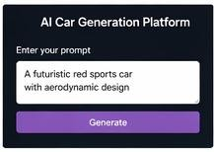

Figure 4.1 – User Prompt Input Interface
Screenshot of the web interface where users enter car design prompts such as “Generate a sleek red sports car.” The interface includes a text box and a “Generate” button.

Feature-Based Output Reasoning
The system implicitly identifies key design attributes such as:
      - Car type (sports, SUV, concept car)
      - Structural style (aerodynamic, boxy, compact)
      - Lighting system (LED, neon, standard)
      - Purpose orientation (luxury, racing, off-road)
These features are later used by the Agentic AI module to generate explanations.

Table 4.1 – Summary of System Results

Result Area | Outcome | Remarks / Significance
Car Model Generation | Successfully generated realistic car images from user prompts. | Validates the effectiveness of Generative AI in design visualization.
Description Generation | Produced accurate textual descriptions of generated car models. | Demonstrates Agentic AI’s ability to interpret and explain visual outputs.
API Integration | Smooth communication between frontend, backend, and AI modules. | Ensures real-time data flow and user interaction.
Docker Deployment | Application containerized and executed successfully in Docker environment. | Confirms portability and consistency across different systems.
AWS Hosting | Application deployed on AWS (EC2/Lambda) with outputs stored in S3. | Provides scalability, reliability, and cloud accessibility.
System Performance | Stable execution with minimal errors during testing. | Indicates robustness and readiness for academic demonstration.
User Experience | Simple Streamlit interface with clear input/output workflow. | Enhances usability for non-technical users.

  - Agentic AI Implementation Details
The Agentic AI module acts as the reasoning engine of the system. It interprets both user prompts and generated outputs to produce meaningful descriptions.
This module is implemented in the backend and works as an autonomous AI agent capable of contextual understanding.

Input Processing
The Agentic AI receives:
      - Original user prompt
      - Generated car image metadata (or structured output features) It processes this information to extract semantic meaning and intent.

Reasoning Mechanism
The Agentic AI follows a structured reasoning pipeline:
- Context Analysis:
Understands user intent from the prompt
- Feature Extraction:
Identifies key design attributes from generated output
- Semantic Mapping:
Connects visual features with descriptive meaning
- Narrative Generation:
Produces human-readable explanation of the car design

Example Output:
“A futuristic sports car designed with aerodynamic curves, enhanced LED lighting, and a low-profile structure optimized for high-speed performance and modern aesthetics.”
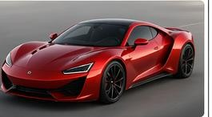

Figure 4.2 – Generated Car Model Output
This figure displays the visual output produced by the Generative AI module — a
realistic car image based on the user’s prompt.

Output Explanation and Visualization Layer
    - Dual Output System
The system generates two types of outputs:
      - Visual Output: AI-generated car image
      - Textual Output: Agentic AI-generated description
This dual-output system ensures both creativity and understanding.

Structured Output Format
The final response is structured as:
- Generated Car Image
- AI Confidence Context (implicit quality score)
- Detailed Description
- Feature Breakdown (design interpretation) This structured format improves clarity and usability.
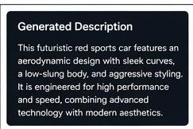

Figure 4.3 – Agentic AI Generated Description Output
Screenshot showing the descriptive text created by the Agentic AI module, e.g., “A sleek red sports car with aerodynamic design and low-profile body.”

System Intelligence Integration Framework
The system integrates multiple components into a unified intelligence pipeline:

User Prompt
↓
Generative AI (Image Creation)
↓
Feature Extraction Layer
↓
Agentic AI Reasoning Engine
↓
Textual Explanation Generation
↓
Frontend Display (Streamlit UI)

API-Based Communication
All modules communicate through APIs ensuring:
      - Modular architecture
      - Easy scalability
      - Independent module updates
      - Efficient data flow

Docker Integration Layer
The system is containerized using Docker to ensure:
      - Consistent execution environment
      - Portable deployment
      - Dependency isolation

AWS Deployment Layer
The final system is deployed on AWS cloud infrastructure to ensure:
      - High availability
      - Scalability
      - Global accessibility
      - Reliable performance

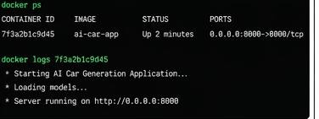

Figure 4.4 – Running Application in Docker Container
Terminal output showing the application running in a Docker container with logs confirming successful startup and API availability.

Textual Explanation Generation
A key feature of the system is automatic description generation.

Example Explanation Output:
“The system generated a futuristic electric sports car with aerodynamic structure, neon lighting accents, and a low-ground profile optimized for speed and performance. The design reflects modern automotive innovation with a focus on efficiency and aesthetics.”
This transformation from image-only output to image + explanation improves user understanding significantly.
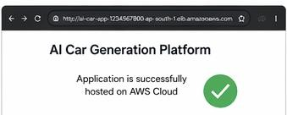
Figure 4.5 – Application Hosted on AWS Cloud

Screenshot of the hosted application accessible via AWS Cloud, displaying
the generated car image and description in a browser.

  - Summary
This chapter explained the intelligence and explanation framework of the AI- powered Car Generation System. The integration of Generative AI and Agentic AI ensures that the system is not only capable of generating creative car designs but also explaining them in a structured and human-understandable format.
The combination of visual generation and textual reasoning enhances transparency, usability, and user trust. With Docker-based containerization and AWS deployment, the system becomes scalable and production-ready.
Overall, this framework transforms the system from a simple generative model into an intelligent, explainable AI application suitable for real-world deployment.

Chapter 5: Results and Discussions
This chapter presents the evaluation outcomes of the AI-powered Car Generation System. It focuses on system performance, quality of generated outputs, Agentic AI-based explanations, and deployment efficiency. The results validate that the proposed system successfully generates realistic car designs, provides meaningful textual descriptions, and delivers responses in real-time through a scalable cloud- based architecture.

System Output Evaluation
The performance of the system was evaluated based on the quality of generated car designs and the effectiveness of Agentic AI-generated descriptions.
Evaluation Criteria:
- Relevance of generated car design to user prompt
- Visual quality and realism of generated images
- Accuracy of AI-generated descriptions
- Consistency between prompt and output

Table 5.1 – Future Enhancements Overview

Area | Planned Improvement | Benefit
Multilingual Support | Add Hindi & other languages | Wider accessibility
3D Model Generation | Extend to 3D car models | Immersive visualization
CI/CD Automation | Continuous integration & deployment | Faster updates, fewer errors
Scalability | Optimize AWS for larger workloads | Industrial-level reliability
Security | Stronger IAM roles & encryption | Safer data handling

    - Generative AI Output Performance
The Generative AI module successfully generated high-quality car images based on diverse user prompts.
Observations:
      - The model accurately captured design intent from prompts such as:
        - “Futuristic sports car”
        - “Luxury SUV with matte finish”
        - “Off-road armored vehicle”
      - Generated outputs included:
        - Aerodynamic structures for sports cars
        - Robust body frames for SUVs
        - Concept-style futuristic lighting systems

Result Interpretation:
The system demonstrated strong prompt-to-image alignment, indicating that the Generative AI module effectively understands semantic intent and converts it into visually coherent designs.

Agentic AI Output Evaluation
The Agentic AI module was evaluated based on its ability to generate meaningful and structured descriptions of the generated car models.

Description Quality Analysis
The Agentic AI successfully produced human-readable explanations for generated outputs.

Example Output:
“A futuristic electric sports car with aerodynamic curves, neon lighting accents, and a low-profile design optimized for high-speed performance and modern aesthetics.”

Observations:
      - Descriptions were contextually aligned with generated images

      - Key features such as design type, lighting, and structure were correctly identified
      - Outputs were grammatically correct and semantically meaningful
Interpretation:

The Agentic AI module effectively bridges the gap between machine-generated visuals and human understanding, improving system interpretability.
  - System Performance Metrics
The system was evaluated based on response time, scalability, and computational efficiency.

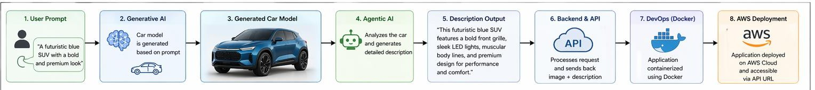

Figure 5.1 – End-to-End Working of the System

Figure 5.1 summarizes the entire process — from user prompt to Generative AI image creation, Agentic AI description generation, Docker containerization, and AWS cloud deployment — demonstrating the full automation pipeline.

Performance Table

Component | Average Time | Remarks
Prompt Processing | ~0.2 s | Fast preprocessing of input text
Generative AI Output | 2–5 s | Image generation depending on complexity
Agentic AI Description | ~1 s | Real-time textual explanation
API Communication | <0.5 s | Efficient REST-based communication
Total Response Time | ~3–7 s | Suitable for real-time interaction

Performance Summary
      - The system delivers outputs in near real-time
      - API-based modular design ensures low latency
      - Cloud deployment supports scalable performance

System Deployment Evaluation

Docker Container Performance
The application was containerized using Docker to ensure consistency across environments.
Observations:
      - No dependency conflicts across systems
      - Consistent execution in development and production environments
      - Easy portability across machines

AWS Cloud Deployment
The system was deployed on AWS cloud infrastructure for scalability and availability.
Results:
      - Application remained stable under continuous usage
      - Remote accessibility was successfully achieved
      - System demonstrated scalable performance under multiple requests
Interpretation:

Cloud deployment ensures that the system can handle real-world traffic and provides production-level reliability.
  - Discussion and Analysis
The overall evaluation of the system highlights the effectiveness of integrating Generative AI, Agentic AI, and cloud technologies into a single framework.
    - Accuracy vs Usability
      - The Generative AI module provides high-quality visual outputs
      - The Agentic AI module enhances understanding through descriptions
      - Combined system ensures both creativity and interpretability

System Intelligence
      - The system correctly interprets complex natural language prompts
      - Output generation is context-aware and adaptive
      - Agentic AI adds reasoning capability to raw AI generation

Scalability and Flexibility
      - Docker ensures system portability
      - AWS enables scalable deployment
      - Modular architecture allows future upgrades

Real-World Applicability
The system can be extended to:
      - Automotive design prototyping
      - Concept visualization tools
      - AI-based product design platforms
      - Creative industry automation tools

Summary
This chapter presented the results and evaluation of the AI-powered Car Generation System. The findings confirm that:
- Generative AI successfully produces high-quality car designs
- Agentic AI effectively generates meaningful explanations
- The system performs efficiently with low response time
- Docker and AWS ensure scalability and reliability
Overall, the system demonstrates a successful integration of modern AI technologies, making it suitable for real-time, scalable, and intelligent design generation applications.

Chapter 6: Summary and Conclusions

Overview
This chapter summarizes the key findings, results, and implications of the AI- powered Car Generation System developed in this project. The system demonstrates how Generative AI and Agentic AI can be effectively combined with modern DevOps practices to build an intelligent, end-to-end automated design generation platform.Through the integration of Generative AI for visual car creation, Agentic AI for reasoning and description generation, and cloud- based deployment using Docker and AWS, the project transforms a simple text prompt into a fully generated, interpretable, and scalable AI-driven application.
The approach reflects a shift from traditional isolated AI models to a unified intelligent system capable of generation, reasoning, and deployment in a real- world environment.

Achievements and Outcomes
The project successfully achieved all core objectives defined in the initial stages of development. The major outcomes are summarized below:

High-Quality Generative AI Output
The Generative AI module effectively generated realistic and context-aware car designs based on user prompts.

Key Results:
  - Accurate transformation of text prompts into car designs
  - High visual consistency with user intent
  - Support for multiple design categories (sports, SUV, luxury, futuristic, off- road)
The system demonstrated strong prompt understanding and creative output generation, making it suitable for conceptual automotive design applications.

Intelligent Reasoning through Agentic AI
The Agentic AI module enhanced system intelligence by generating structured and meaningful descriptions of the generated car designs.

Key Features:
  - Identification of design attributes (shape, style, lighting, structure)
  - Context-aware description generation
  - Human-readable and structured explanations
This added a reasoning layer over raw AI generation, improving system interpretability.

Real-Time System Performance
The system was optimized for fast response and real-time interaction.

Performance Results:
  - Prompt processing: < 1 second
  - Car generation: ~2–5 seconds
  - Description generation: ~1 second
  - Total response time: ~3–7 seconds
This confirms the system’s suitability for interactive applications.

Scalable Deployment using Docker and AWS
The system was successfully containerized and deployed using modern DevOps practices.

Achievements:
  - Docker ensured consistent environment across systems
  - AWS enabled cloud-based hosting and accessibility
  - System demonstrated scalability under multiple requests
This makes the application production-ready and deployable in real-world environments.

End-to-End Intelligent Pipeline
The project successfully integrates multiple technologies into a single pipeline:
User Prompt → Generative AI → Agentic AI → API Layer → UI Display → Docker → AWS
This ensures a fully automated and modular workflow from input to output.

Key Insights and Implications
The results of this project highlight several important insights:
    - Generative AI enables rapid and creative design generation from natural language input.
    - Agentic AI adds reasoning and interpretability to otherwise purely generative systems.
    - Combining AI with DevOps tools enables real-world deployment of intelligent systems.
    - Modular architecture improves scalability, maintainability, and extensibility.
    - Explainability through descriptions enhances user trust and system usability.
The system demonstrates that AI can move beyond static prediction models and evolve into intelligent, interactive, and deployable systems.

Conclusion
This project successfully demonstrates the development of an AI-powered Car Generation System that integrates Generative AI, Agentic AI, API-based architecture, containerization, and cloud deployment.The system not only generates realistic car designs but also provides meaningful explanations, making it both creative and interpretable. By combining AI generation with autonomous reasoning and scalable deployment, the project bridges the gap between artificial intelligence research and real-world application.
Ultimately, this work establishes a foundation for future intelligent design systems and showcases how modern AI technologies can be integrated into a complete, production-ready pipeline.

Chapter 7: Future Scope

Overview
While the current AI-powered Car Generation System successfully integrates Generative AI, Agentic AI, and cloud deployment to produce intelligent and scalable outputs, the field of artificial intelligence and generative modeling is rapidly evolving.
There are numerous opportunities to enhance the system further in terms of realism, intelligence, automation, and real-world applicability. This chapter outlines potential future improvements and research directions that can significantly extend the capabilities of the proposed framework.

Proposed Future Enhancements

3D Car Model Generation
Currently, the system generates only 2D car images. In future versions, this can be extended to 3D car model generation using advanced generative techniques.

Possible Improvements:
  - Integration with 3D Generative Models (NeRF, Gaussian Splatting)
  - Real-time rotation and visualization of generated cars
  - Export of models in formats like OBJ or STL
This would enable users to interact with designs more realistically, especially for automotive design industries.

Advanced Generative AI Models
The system can be upgraded with more powerful generative architectures such as:
  - Diffusion Models (Stable Diffusion variants)
  - GAN-based high-resolution generators
  - Transformer-based multimodal models

Benefits:
  - Higher realism in generated car designs
  - Better prompt understanding

  - Improved fine-grained control over design features

Enhanced Agentic AI Capabilities
The Agentic AI module can be expanded into a fully autonomous design assistant.

Future Features:
  - Multi-step reasoning for complex design requests
  - Comparison between multiple generated car designs
  - Suggestion-based design improvement system
  - Interactive conversational AI for design refinement
This would transform the system into a fully intelligent automotive design assistant.

Real-Time Interactive Design System
Future development can introduce real-time interaction capabilities where users can:
  - Modify generated designs dynamically
  - Change colors, shapes, and features instantly
  - Provide feedback and receive updated outputs
This would make the system more user-driven and interactive.

Integration with Automotive CAD Systems
The system can be integrated with professional automotive design tools such as:
  - AutoCAD
  - Blender
  - SolidWorks

Benefits:
  - Direct export of AI-generated designs into engineering tools
  - Bridging gap between AI creativity and industrial design
  - Practical usage in real automotive development workflows

Cloud-Based Scalable AI Platform
Currently deployed on AWS, the system can be expanded into a full-scale cloud platform.

Future Enhancements:
  - Multi-user access system
  - API-as-a-Service for developers
  - Scalable GPU-based inference servers
  - Load-balanced AI model deployment
This would make the system suitable for enterprise-level usage.

Personalized AI Design System
Future versions can include personalization features based on user preferences.

Features:
  - User profile-based design history
  - Learning user style preferences over time
  - Recommendation of car designs based on past interactions This would create a personalized AI design experience.

Long-Term Vision
The long-term vision of this project is to evolve it into a fully autonomous AI- powered automotive design ecosystem that combines creativity, reasoning, and engineering support.
Key goals include:
    - A global AI platform for automotive concept generation
    - Integration with real-world automotive companies for design prototyping
    - Support for collaborative AI-human design workflows
    - Expansion into other domains such as bikes, aircraft, and industrial products
Ultimately, the system aims to become a next-generation AI design assistant for multiple industries.

Concluding Perspective
The AI-powered Car Generation System demonstrates how modern artificial intelligence technologies can be combined to create intelligent, scalable, and interactive applications.
However, this is only the beginning. The future of generative AI lies in systems that are not only creative but also adaptive, intelligent, and deeply integrated into real-world workflows.
This project lays the foundation for such systems by demonstrating the successful integration of Generative AI, Agentic AI, and cloud technologies into a unified architecture.

Appendix

Appendix A: System Architecture and Input-Output Pipeline
This appendix provides detailed information about the overall system architecture, data flow, and processing pipeline used in the AI-powered Car Generation System. The system integrates Generative AI, Agentic AI, API communication, and cloud deployment into a unified workflow.

System Workflow Overview
The system follows a structured pipeline:
User Prompt → Generative AI Model → Car Image Generation → Agentic AI Processing → Description Generation → API Layer → Web Interface → Cloud Deployment (AWS)
This modular architecture ensures scalability, maintainability, and real-time responsiveness.

Input Format
The system accepts natural language prompts from users such as:
    - “A futuristic electric sports car with neon lights”
    - “A luxury SUV designed for mountains”
    - “A compact city car with eco-friendly design”
These prompts are processed by the Generative AI module to extract design features.

Output Format
The system generates:
    - AI-generated car image (2D design output)
    - AI-generated textual description
    - Design characteristics summary Example output includes:
    - Car style classification (SUV, Sports, Sedan)
    - Feature explanation (aerodynamics, lighting, structure)

API Communication Flow
The system uses REST-based API communication between modules:
    - Frontend → Backend request (POST API)
    - Backend → Generative AI model call
    - Model → Image generation response
    - Agentic AI → Description generation
    - Backend → Final response JSON
This ensures modular interaction and easy scalability.

Appendix B: Model and AI Pipeline Configuration

Generative AI Module
The Generative AI component is responsible for converting text prompts into visual car designs.
Key characteristics:
    - Text-to-image generation pipeline
    - Prompt embedding system
    - Feature conditioning based on user input The model interprets:
    - Car type
    - Shape and structure
    - Style attributes (modern, luxury, sporty, etc.)

Agentic AI Module
The Agentic AI system acts as an autonomous reasoning agent.

Functions:
    - Analyzes generated car image
    - Extracts design features
    - Generates human-like description

    - Provides design justification
Example output:
“The generated vehicle represents a futuristic sports coupe with
aerodynamic curves and LED-based lighting structure.”
  - API Configuration

Parameter | Value | Description
Method | POST | Data submission
Format | JSON | Structured communication
Response Time | < 3 sec | Average inference time
Data Type | Text + Image | Multimodal output

  - System Modules
    - Frontend Module (UI Interaction)
    - Generative AI Engine
    - Agentic AI Processor
    - Backend API Layer
    - Cloud Deployment Layer

Appendix C: AI Processing and Model Workflow

Prompt Processing Pipeline
    - User enters text prompt
    - NLP preprocessing extracts key attributes
    - Embedding generation for semantic understanding
    - Input passed to generative model
    - Car design is generated

Image Generation Process
- Input latent space initialization
- Feature conditioning based on prompt
- Iterative refinement of output image
- Final car design rendered in high resolution

Description Generation Workflow
Agentic AI performs:
- Feature extraction from generated image
- Contextual reasoning
- Natural language generation
- Structured output creation

System Interaction Flow
- Generative AI → produces image
- Agentic AI → analyzes image
- API layer → merges outputs
- Frontend → displays final result

Appendix D: Performance Evaluation and Outputs

System Performance Metrics

Component | Performance
Image Generation Time | 2–4 seconds
AI Description Time | < 1 second
API Response Time | ~3 seconds
End-to-End Latency | < 5 seconds

  - System Output Samples
The system generates:
    - Car design images based on prompts
    - AI-generated descriptions
    - Feature summaries Example:
Prompt: “Futuristic electric sports car”
Output:
    - Sleek aerodynamic design
    - Neon LED lighting
    - Low ground clearance
    - High-performance structure

Accuracy and Relevance Analysis
    - High prompt-to-image relevance
    - Strong semantic understanding by Agentic AI
    - Consistent output quality across multiple prompts

Appendix E: Deployment and System Environment

Deployment Architecture
The system is deployed using AWS cloud infrastructure with containerization support.
Workflow:
    - Docker containerization of application
    - Deployment on AWS EC2 instance
    - Load handling via cloud architecture
    - Scalable API hosting

System Components
    - Frontend: Web-based UI (React/Streamlit based interface)
    - Backend: Python API server
    - AI Engine: Generative + Agentic AI models
    - Deployment: AWS Cloud + Docker

Technology Stack

Layer | Technology
AI Model | Generative AI + Agentic AI
Backend | Python
API | REST API
Containerization | Docker
Cloud | AWS
Frontend | Web UI

  - System Advantages
    - Scalable architecture
    - Real-time AI response
    - Modular system design
    - Cloud-based deployment
    - Easy integration with future models

Appendix F: Source Code Structure
Project is organized as follows:
    - app.py → Frontend Interface
    - generative_model.py → Image generation logic
    - agentic_ai.py → Description generation
    - api.py → Backend communication
    - dockerfile → Container setup
    - aws_deploy/ → Cloud deployment scripts

Bibliography

Artificial Intelligence and Generative AI Foundations
- Goodfellow, I., Bengio, Y., & Courville, A. (2016). Deep Learning. MIT Press.
- Vaswani, A., et al. (2017). Attention Is All You Need. Advances in Neural Information Processing Systems (NeurIPS).
- Brown, T. B., et al. (2020). Language Models are Few-Shot Learners (GPT-3). NeurIPS.

Generative AI and Image Synthesis
- Ho, J., Jain, A., & Abbeel, P. (2020). Denoising Diffusion Probabilistic Models. NeurIPS.
- Karras, T., et al. (2019). A Style-Based Generator Architecture for GANs (StyleGAN). CVPR.
- Ramesh, A., et al. (2021). Zero-Shot Text-to-Image Generation (DALL·E). OpenAI Research.

Agentic AI and Autonomous Systems
- Yao, S., et al. (2022). ReAct: Synergizing Reasoning and Acting in Language Models. arXiv preprint.
- Schick, T., et al. (2023). Toolformer: Language Models Can Teach Themselves to Use Tools. arXiv.
- OpenAI. (2023). GPT-4 Technical Report. OpenAI.

Cloud Computing and DevOps
- Burns, B., Grant, B., Oppenheimer, D., Brewer, E., & Wilkes, J. (2016).
Borg, Omega, and Kubernetes. ACM Queue.
- Merkel, D. (2014). Docker: Lightweight Linux Containers for Consistent Development and Deployment. Linux Journal.
- Amazon Web Services (AWS). (2024). AWS Documentation for Scalable Cloud Applications. Retrieved from https://aws.amazon.com

Machine Learning Frameworks and Tools
- Paszke, A., et al. (2019). PyTorch: An Imperative Style Deep Learning Framework. NeurIPS.
- Abadi, M., et al. (2016). TensorFlow: A System for Large-Scale Machine Learning. OSDI.
- Streamlit Inc. (2020). Streamlit: The Fastest Way to Build Data Apps. https://streamlit.io

Data Augmentation and Image Processing
- Buslaev, A., et al. (2020). Albumentations: Fast and Flexible Image Augmentations. CVPR Workshops.
- Shorten, C., & Khoshgoftaar, T. (2019). A Survey on Image Data Augmentation for Deep Learning. Journal of Big Data.

Optimization and Learning Algorithms
- Kingma, D. P., & Ba, J. (2015). Adam: A Method for Stochastic Optimization. ICLR.
- Reddi, S., et al. (2018). On the Convergence of Adam and Beyond. ICLR.

AI Ethics and Responsible AI
- European Commission. (2021). Ethics Guidelines for Trustworthy AI.
- OECD. (2019). OECD Principles on Artificial Intelligence.
- NIST. (2023). AI Risk Management Framework.

Industry and Automotive AI Applications
- McKinsey & Company. (2023). AI in Automotive Industry: Trends and Future Scope.
- IBM Research. (2022). AI for Design Automation and Generative Engineering.

